COMPUTER SCIENCE PROJECT FILE

A RACING VIDEO GAME

ESCAPED DERELICTS


Class/Section: XIIth A
Group members:
1. Jainil Desai
2. Kushagra Sinha
3. Aabha Tripathi
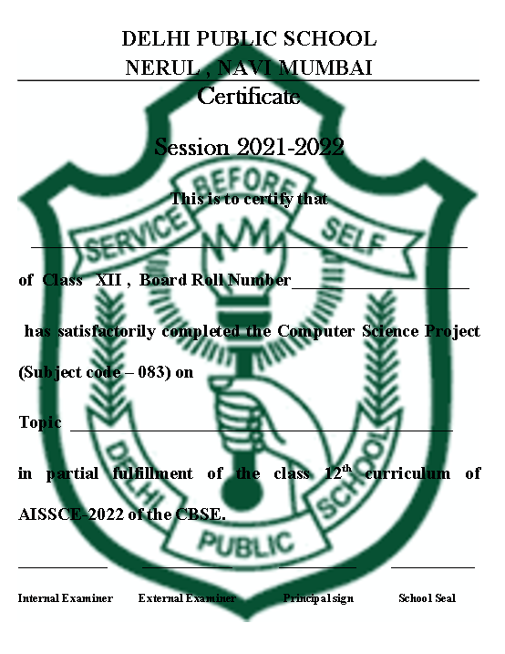

Acknowledgement

I hereby thank the school and the staff of the computer department for all the guidance and support extended to me during the course of this project.

My special thanks are due to the Principal for providing us with a right platform and environment to complete the project.

My sincere thanks to Ms. Radhika Sridhar our Computer Science teacher for her able guidance , unflinching support and the affectionate touch without which this project would not have been a success.

Finally I thank all those who have directly or indirectly contributed to the success of this project.

Jainil Desai
Roll no. 15608128

Hardware Requirements:

Processor: Intel Pentium/AMD ATHLON
RAM: 4GB
GPU: INTEL HD GRAPHICS/RADEON VEGA
HDD: 32GB
Software Requirements:

Operating System: Windows 10 and above
Python 3.7
Word file reader

Python(Pygame):
Python is an interpreted high-level programming language. In this case, "high level" means further from machine code. "High level" doesn't mean it is harder - actually, high-level languages are generally easier to use than low-level languages like C. As a language, Python can be written in an Object-Oriented Style (which should be familiar if you're from the C++/C#/Java side of things), but it also supports other programming paradigms - or other ways of structuring and writing code. I prefer writing games using Object Oriented techniques.
Python consistently ranks as one of the most popular programming languages.
PyGame is a library that can be used with Python. A library is pre-written code that can be reused in multiple programs. This usually includes functions and classes that provide new functionality.
PyGame handles features like:
- Loading and drawing graphics
- Loading and playing sounds
- Loading fonts and drawing text
- Detecting keyboard and mouse input

Synopsis:
‘Escaped derelicts’ is a 2D racing game developed by Jainil, Kushagra and Abha (RAM02). The game will be solely developed in python, using pygame.
Game Description: You are on the road with an enormous amount of bounty on your head as you have unknowingly stolen a mafia boss’s Ferrari parked in the casino of Las Vegas. You escape through the highway in the scorching desert of Nevada, Death Valley. You seem like you escaped but the mafia boss catches up to you and tries to stop you by getting his thugs to ram several cars at you. Evade the gang members and make sure you don’t crash! And keep your eyes peeled as they tend to get aggressive.
Features:
-A ‘NOSTALGIC’ type desert
-A point system
Objectives:
- You are in the stolen car.
- Avoid crashing your car to the thug’s cars and don’t let the mafia gang member ram you to a halt.
- Rack up enough points and compete with your friends to get the highest score

Code:
import random
from time import sleep

import pygame

class CarRacing:
def __init__(self):

from pygame import mixer
pygame.init()
mixer.music.load(r'D:/Stuff/Studies/School/Assignments/Escaped Derelicts/background.mp3')
mixer.music.play(-1)
self.display_width = 512
self.display_height = 512
self.black = (0, 0, 0)
self.white = (255, 255, 255)
self.clock = pygame.time.Clock()
self.gameDisplay = None

self.initialize()

def initialize(self):

self.crashed = False

self.carImg = pygame.image.load(r'D:/Stuff/Studies/School/Assignments/Escaped Derelicts/player.png')
self.car_x_coordinate = (self.display_width * 0.45)
self.car_y_coordinate = (self.display_height * 0.8)
self.car_width = 61

# enemy_car
self.enemy_car = pygame.image.load(r'D:/Stuff/Studies/School/Assignments/Escaped Derelicts/mafia.png')
self.enemy_car_startx = random.randrange(79, 438)
self.enemy_car_starty = -300
self.enemy_car_speed = 5
self.enemy_car_width = 42
self.enemy_car_height = 88

# Background
self.bgImg = pygame.image.load(r"D:/Stuff/Studies/School/Assignments/Escaped Derelicts/background2.png")
self.bg_x1 = (self.display_width / 2) - (512 / 2)
self.bg_x2 = (self.display_width / 2) - (512 / 2)
self.bg_y1 = 0
self.bg_y2 = -512
self.bg_speed = 3
self.count = 0

def car(self, car_x_coordinate, car_y_coordinate):
self.gameDisplay.blit(self.carImg, (car_x_coordinate, car_y_coordinate))

def racing_window(self):
self.gameDisplay = pygame.display.set_mode((self.display_width, self.display_height))
pygame.display.set_caption('Escaped Derelicts')
icon = pygame.image.load(r'D:/Stuff/Studies/School/Assignments/Escaped Derelicts/logo.png')
pygame.display.set_icon(icon)
self.run_car()

def run_car(self):

while not self.crashed:

for event in pygame.event.get():
if event.type == pygame.QUIT:
self.crashed = True
pygame.quit()
# print(event)

if (event.type == pygame.KEYDOWN):
if (event.key == pygame.K_LEFT):
self.car_x_coordinate -= 50
if (event.key == pygame.K_RIGHT):
self.car_x_coordinate += 50

self.gameDisplay.fill(self.black)
self.back_ground_road()

self.run_enemy_car(self.enemy_car_startx, self.enemy_car_starty)
self.enemy_car_starty += self.enemy_car_speed

if self.enemy_car_starty > self.display_height:
self.enemy_car_starty = 0 - self.enemy_car_height
self.enemy_car_startx = random.randrange(74, 424)

self.car(self.car_x_coordinate, self.car_y_coordinate)
self.highscore(self.count)
self.count += 1
if (self.count % 100 == 0):
self.enemy_car_speed += 1
self.bg_speed += 1

if self.car_y_coordinate < self.enemy_car_starty + self.enemy_car_height:
if self.car_x_coordinate > self.enemy_car_startx and self.car_x_coordinate < self.enemy_car_startx + self.enemy_car_width or self.car_x_coordinate + self.car_width > self.enemy_car_startx and self.car_x_coordinate + self.car_width < self.enemy_car_startx + self.enemy_car_width:
self.crashed = True
self.display_message("Game Over !!!")

if self.car_x_coordinate < 74 or self.car_x_coordinate >424 :
self.crashed = True
self.display_message("Game Over !!!")

pygame.display.update()
self.clock.tick(60)

def display_message(self, msg):
font = pygame.font.SysFont("comicsansms", 72, True)
text = font.render(msg, True, (255, 255, 255))
self.gameDisplay.blit(text, (255 - text.get_width() // 2, 267 - text.get_height() // 2))
pygame.display.update()
self.clock.tick(60)
sleep(1)
car_racing.initialize()
car_racing.racing_window()

def back_ground_road(self):
self.gameDisplay.blit(self.bgImg, (self.bg_x1, self.bg_y1))
self.gameDisplay.blit(self.bgImg, (self.bg_x2, self.bg_y2))

self.bg_y1 += self.bg_speed
self.bg_y2 += self.bg_speed

if self.bg_y1 >= self.display_height:
self.bg_y1 = -512

if self.bg_y2 >= self.display_height:
self.bg_y2 = -512

def run_enemy_car(self, thingx, thingy):
self.gameDisplay.blit(self.enemy_car, (thingx, thingy))

def highscore(self, count):
font = pygame.font.SysFont("lucidaconsole", 20)
text = font.render("Score : " + str(count), True, self.white)
self.gameDisplay.blit(text, (0, 0))

if __name__ == '__main__':
car_racing = CarRacing()
car_racing.racing_window()

OutPut Screens:
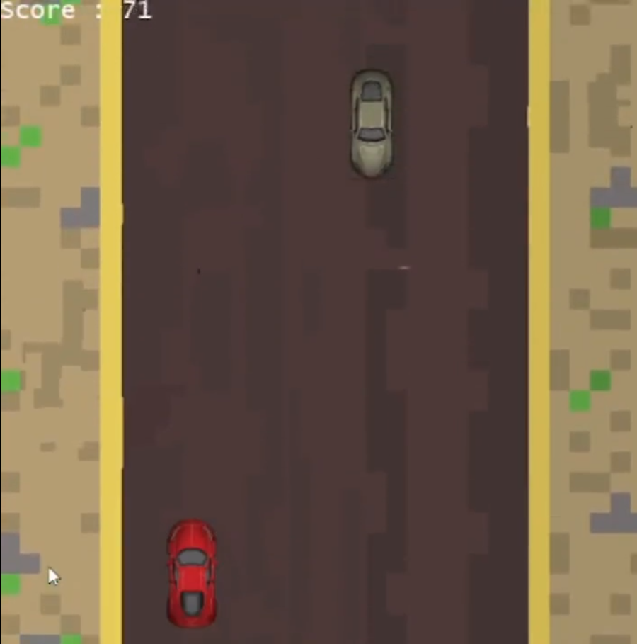
1. Normal Game Screen

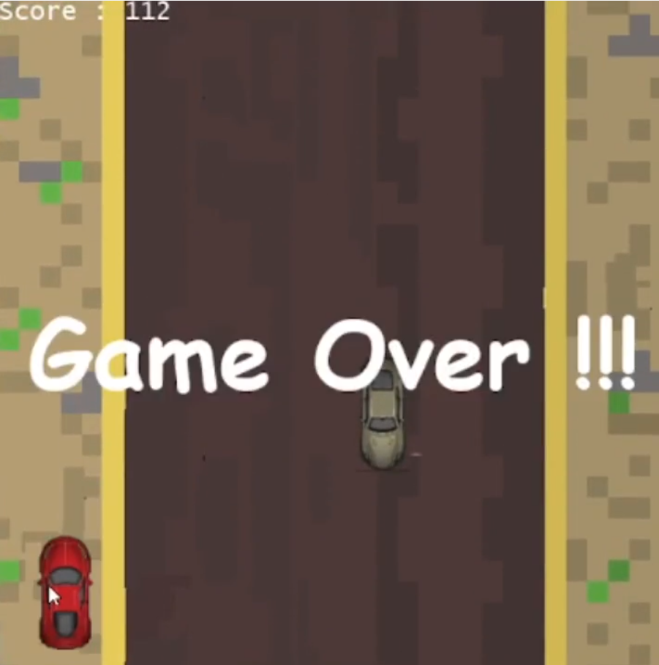
2. Crash Game Screen when driving off the left side of the road

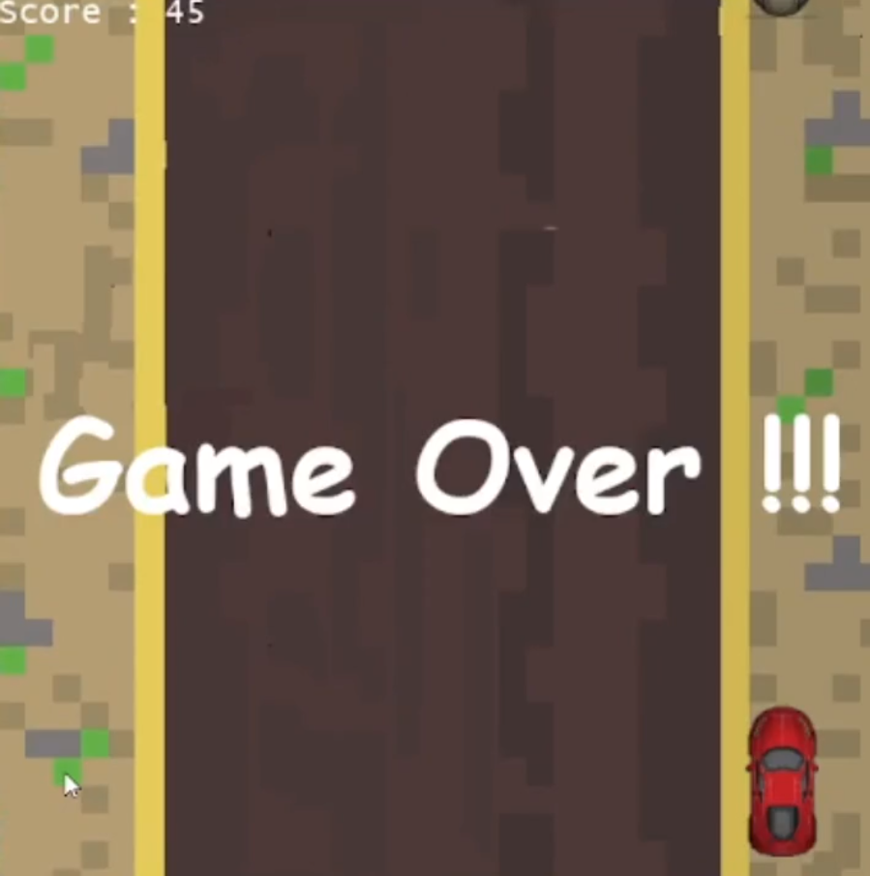
3. Crash Game Screen when driving off the right side of the road

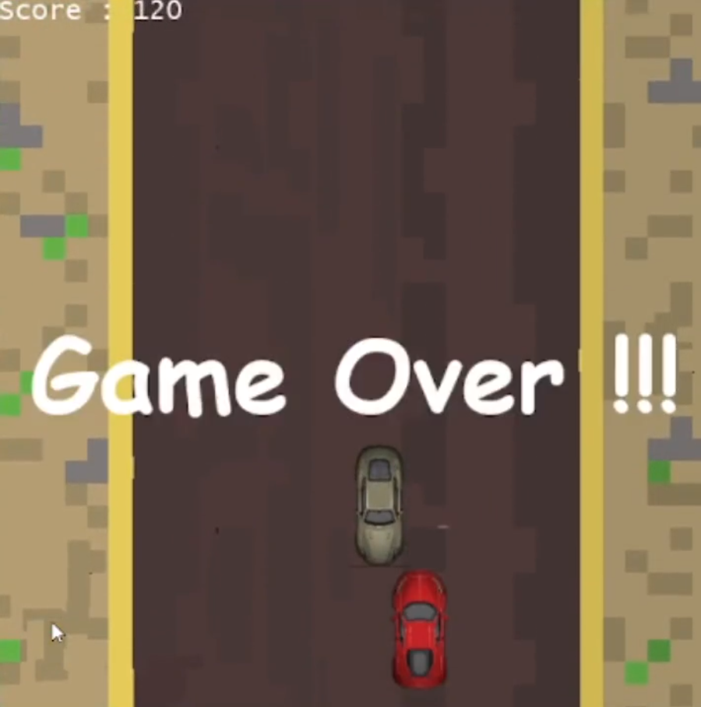
4. Crash Game Screen when ramming into
the thug’s car.

DECLARATION

I , Jainil Desai Board, roll No 15608128 a student of DPS , Navi mumbai humbly submit that I have completed the project work as described in this report by my own skill and study as per the instructions of my teacher Ms. Radhika Sridhar and that I have not copied the report or its any appreciable parts from any other literature in contravention of the academic ethics.

DATE :

SIGNATURE OF THE STUDENT:

